

Project Report
1. Introduction:
  - Overview:
      - This project is about a construction company called Dream Homes Realty Maintaining their Financial Accounts.

1.2 Purpose:
      - This project is been done with the help of Zoho
      - Books where Financial Accounts can be prepared and with the pictorial representation of our companies Financial Position.
2. Problem Definition and Design Thinking:
2.1 Empathy Map
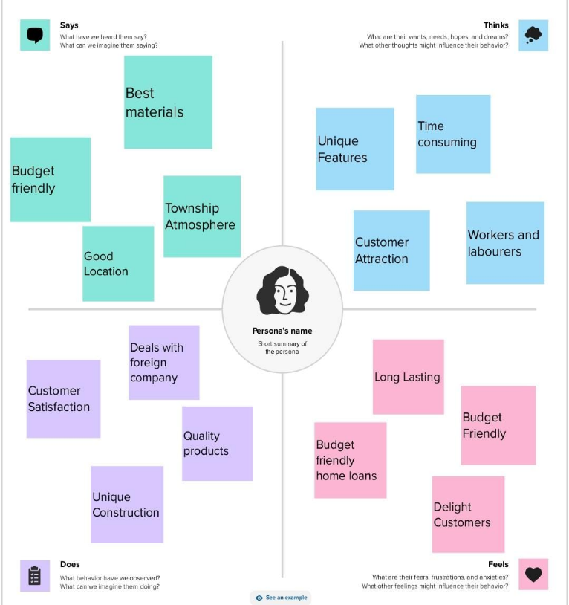
2.2 Ideation and brainstorming map
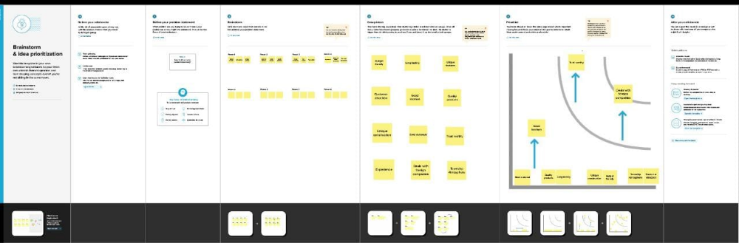
3. Result:
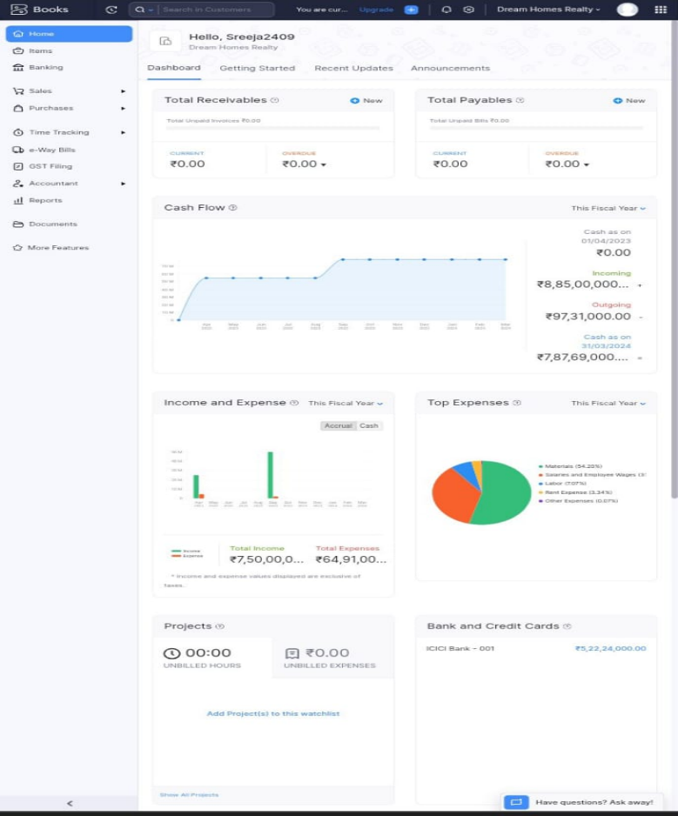
4. Advantages and Disadvantages:
Advantages
- It helps to maintain the financial accounts of our company and also tracks the companies billing
- It helps to calculate accurately project costs, monitor profitability and also generates financial reports
Disadvantages:
- Takes long time for making proper reports
5. Applications:
This applications can be applied to any type of companies and firms to track their expenses and billings and also this software helps in maintaining the financial reports of the companies
6. Conclusion:
In this project we had used Zoho books as the application for preparing the financial reports of our company Dream Homes Realty and also we had created each and every needed items, purchases, sales and also banking entries with the help of the application Zoho books
7. Future Scope
. we would provide better pricing system and provide collaboration with eco -friendly companies who are dealing legally and provide you with better expiriences..

